**Make Me A Playlist:**

**Design:**

For this project we will be developing a website that will help the users with songs and artist recommendations according to their personal taste. Since it is not always easy to find good new songs/artists, we will provide a platform that helps our users find their perfect playlist. In addition to that, the website will also display information about the artists and songs that the user search for. Here follows a sketch of what the user will see when first entering our website:

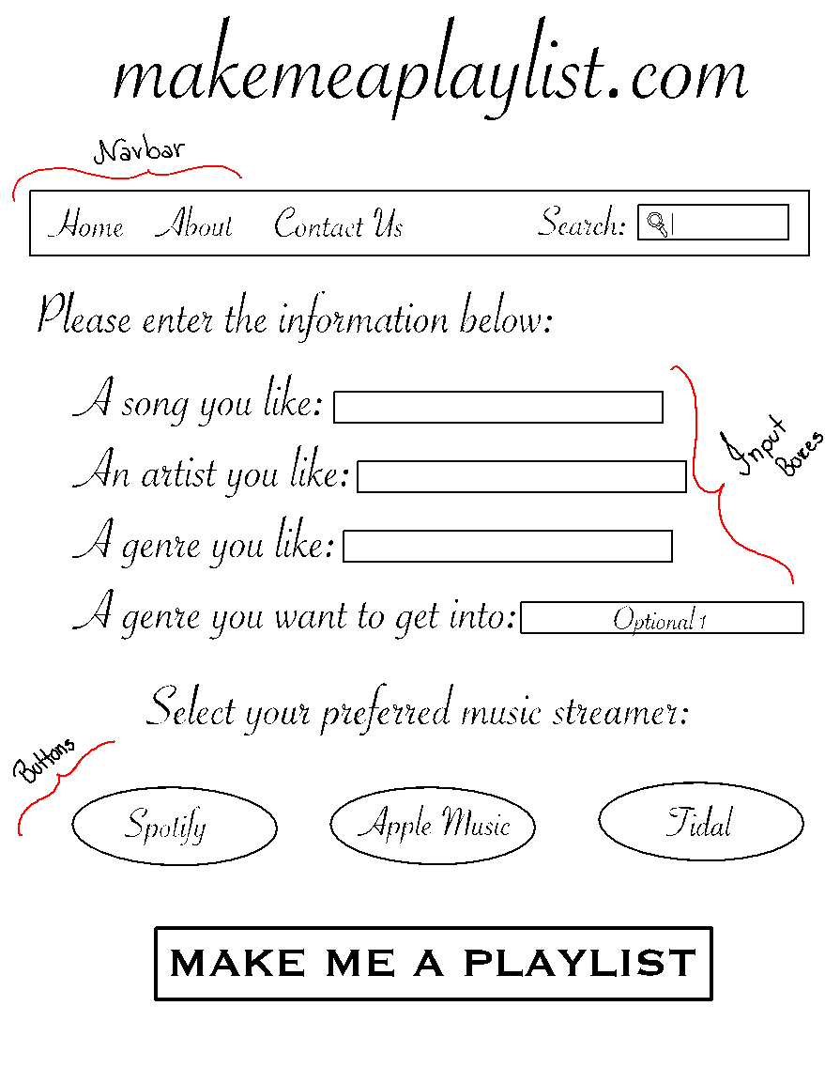

In the Navbar (which will be displayed in all our webpages), the user will have the options to go to the “home” page (which is the one sketched), to learn more “about” us (we will create a separate page for that where we will provide the users with the website information and creators information), “contact us” that will open their email box and allow them to send us a message, and a “search box” where the user can search about their favorite artists and songs. The input boxes will allow the users to input information about their musical taste. Finally, we have the buttons that the user will click to select their preferred platform and make their playlist.

**Development:**

For the development of this website, we will be using JavaScript as our programming language. We will also use HTML (Markup Language) and PHP (Script Language) to better design our website. When choosing our language, we decided that to create a website those would be ideal since it is the most used nowadays when developing a webpage. We also thought about our familiarity with the language seeing a great opportunity to learn and grow as programmers. Since most of us have little or no experience with those languages working on this project will give us an extra tool when moving forward in our career.

We expect learning not only how to develop a website but also how to style it in a user-friendly way, creating an easy platform for people to go in and find their ideal playlist. We believe that will be easy to implement the design of the webpage since we already have an idea of how we want it to look like. On the other hand, a challenge that we might face is learning how to use other servers’ libraries and linking it to our website.

By the end of the semester and our final presentation we plan on having the website published and accessible for everyone. We will also demonstrate it in class by taking volunteers for the inputs and showing how the result playlist changes with different inputs.

**Team Members:**

* **Bruna** – Linking library to our webserver. (JavaScript and HTML).
* **Ilisha** – Integrate HTML into PHP (Help with JavaScript).
* **Nicole** - Focus on integrating the JavaScript (Help with HTML and PHP).